­­



**DIGITAL DESIGN**

**ASSIGNMENT REPORT**

**ASSIGNMENT ID : 1**

**Student Name: 李子南**

**Student ID: 12011517**

PART 1: DIGITAL design THEORY

Provide your answers here:



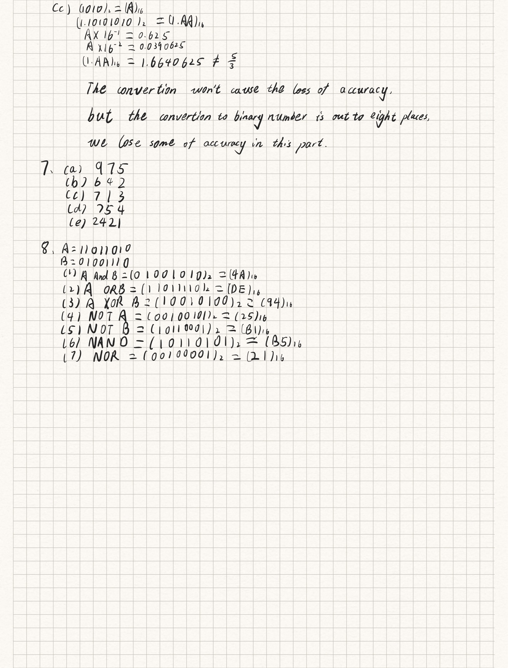

PART 2: DIGITAL design LAB (Task1)

##### Design

*Describe the design of your system by providing the following information:*

* *Verilog design (provide the Verilog code)*
* *Truth-table*

### Task1_designfile

module UnsignedAddition(addend, augend, sum);  
parameter WIDTH =1;  
input [WIDTH-1:0]addend,augend;   
output [WIDTH:0] sum;  
assign sum=addend+augend;  
endmodule

### Truth_table_1bit

| addend | augend | sum |
| --- | --- | --- |
| 0 | 0 | 0 |
| 1 | 0 | 1 |
| 0 | 1 | 1 |
| 1 | 1 | 2(10) |

### Truth_table_2bit

| addend | augend | sum |
| --- | --- | --- |
| 00 | 00 | 00 |
| 00 | 01 | 01 |
| 00 | 10 | 2(10) |
| 00 | 11 | 3(11) |
| 01 | 00 | 01 |
| 01 | 01 | 2(10) |
| 01 | 10 | 3(11) |
| 01 | 11 | 4(100) |
| 10 | 00 | 2(10) |
| 10 | 01 | 3(11) |
| 10 | 10 | 4(100) |
| 10 | 11 | 5(101) |
| 11 | 00 | 3(11) |
| 11 | 01 | 4(100) |
| 11 | 10 | 5(101) |
| 11 | 11 | 6(110) |

##### simulation

*Describe how you build the test bench and do the simulation.*

* *Using Verilog(provide the Verilog code)*
* *Wave form of simulation result (provide screen shots)*
* *The description on whether the simulation result is same as the truth-table, is the function of the design meet the expectation.*

### Task1_1bit_sim

module UnsignedAddition_sim();  
 reg[0:0] A, B;  
 wire[1: 0] C;  
 UnsignedAddition Add(A, B, C);  
 initial  
 begin  
 A = 'b0;B = 'b0;  
 #10 A = 'b1;B = 'b0;  
 #10 A = 'b0;B = 'b1;  
 #10 A = 'b1;B = 'b1;  
 end;  
 initial #40 $finish;  
endmodule;

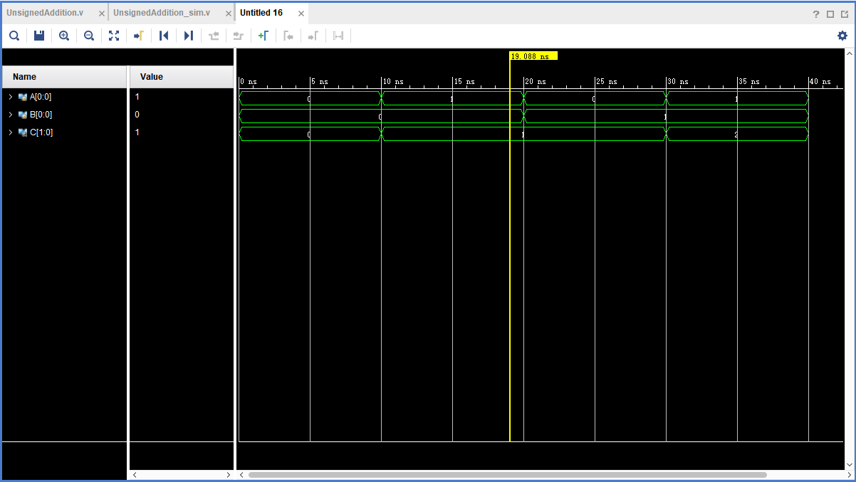

**The result of simulation is the same as the truth table, the function of the design meets the expectation correctly.**

### Task1_2bit_sim

module UnsignedAddition_sim();  
 reg[1:0] A, B;  
 wire[2: 0] C;  
 UnsignedAddition #(2)Add(A, B, C);  
 initial  
 begin  
 A = 'b00;B = 'b00;  
 #10 A = 'b00;B = 'b01;  
 #10 A = 'b00;B = 'b10;  
 #10 A = 'b00;B = 'b11;  
 #10 A = 'b01;B = 'b00;  
 #10 A = 'b01;B = 'b01;  
 #10 A = 'b01;B = 'b10;  
 #10 A = 'b01;B = 'b11;  
 #10 A = 'b10;B = 'b00;  
 #10 A = 'b10;B = 'b01;  
 #10 A = 'b10;B = 'b10;  
 #10 A = 'b10;B = 'b11;  
 #10 A = 'b11;B = 'b00;  
 #10 A = 'b11;B = 'b01;  
 #10 A = 'b11;B = 'b10;  
 #10 A = 'b11;B = 'b11;  
 end;  
 initial #160 $finish;  
endmodule;

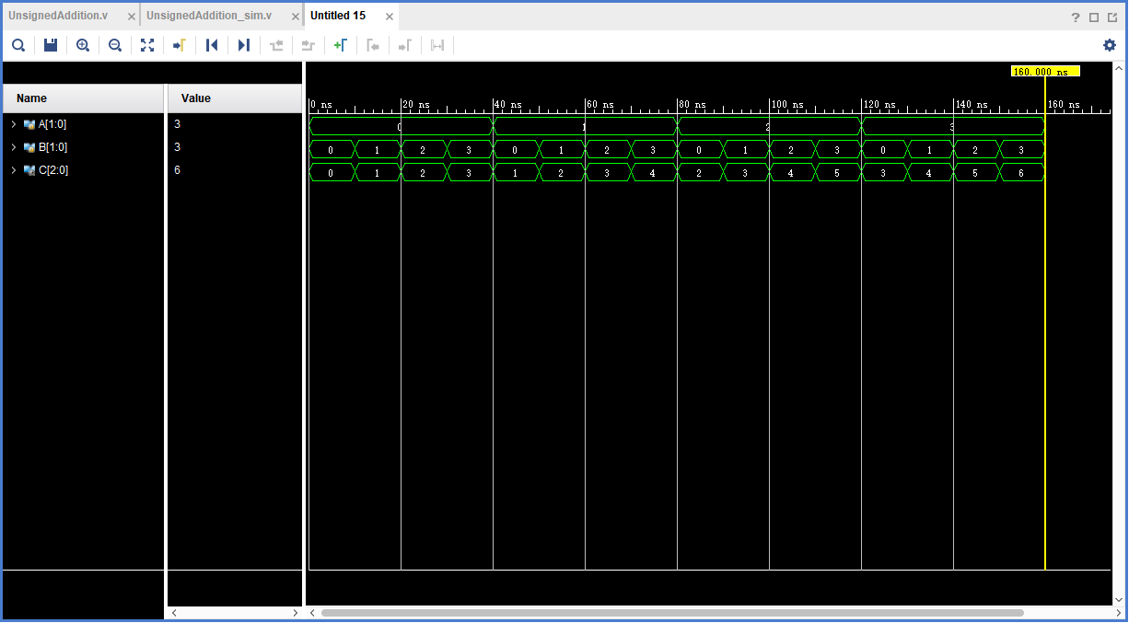

**The result of simulation is the same as the truth table, the function of the design meets the expectation correctly.**

##### the description of operation

*Describe the problem occurred while in the lab and your solution. Any suggestions are welcomed.*

* *Problems and solutions*

**At first, I had problem that the value of C is always X, than I take a look at the video on bb. I found that the bitwise of C was wrong.**

**After I fix this problem, the program work in a right way.**

PART 2: DIGITAL design LAB (Task2)

##### Design

*Describe the design of your system by providing the following information:*

* *Verilog design while using data flow (provide the Verilog code)*
* *Verilog design while using structured design (provide the Verilog code)*
* *Truth-table*

### (A)

#### distributive1bit_df.v

`timescale 1ns / 1ps  
module distributive1bit_df(A,B,C,D,E);  
 parameter X = 1;  
 input[X-1:0] A;  
 input[X-1:0] B;  
 input[X-1:0] C;  
 output[X-1:0] D;  
 output[X-1:0] E;  
 assign D = A & (B | C);  
 assign E = (A & B) | (A & C);   
endmodule

#### distributive2bit_df.v

`timescale 1ns / 1ps  
module distributive2bit_df(A,B,C,D,E);  
 parameter X = 2;  
 input[X-1:0] A;  
 input[X-1:0] B;  
 input[X-1:0] C;  
 output[X-1:0] D;  
 output[X-1:0] E;  
 assign D = A & (B | C);  
 assign E = (A & B) | (A & C);   
endmodule

#### distributive1bit_sd.v

`timescale 1ns / 1ps  
module distributive1bit_sd(A,B,C,D,E);  
 parameter X = 1;  
 input[X - 1:0]A, B, C;  
 output[X - 1:0]D, E;  
 wire[X - 1: 0] tmp1, tmp2, tmp3;  
 or or1(tmp1, B, C);  
 and and1(D, A, tmp1);  
 and and2(tmp2, A, B);  
 and and3(tmp3, A, C);  
 or or2(E, tmp2, tmp3);  
endmodule

#### distributive2bit_sd.v

`timescale 1ns / 1ps  
module distributive2bit_sd(A,B,C,D,E);  
 parameter X = 2;  
 input[X - 1:0]A, B, C;  
 output[X - 1:0]D, E;  
 wire[X - 1: 0] tmp1, tmp2, tmp3;  
 or or1(tmp1[0], B[0], C[0]);  
 or or2(tmp1[1], B[1], C[1]);  
 and and1(D[0], A[0], tmp1[0]);  
 and and2(D[1], A[1], tmp1[1]);  
 and and3(tmp2[0], A[0], B[0]);  
 and and4(tmp2[1], A[1], B[1]);  
 and and5(tmp3[0], A[0], C[0]);  
 and and6(tmp3[1], A[1], C[1]);  
 or or3(E[0],tmp2[0], tmp3[0]);  
 or or4(E[1],tmp2[1], tmp3[1]);  
endmodule

#### Truth_table_1bit

| A | B | C | D | E |
| --- | --- | --- | --- | --- |
| 0 | 0 | 0 | 0 | 0 |
| 0 | 0 | 1 | 0 | 0 |
| 0 | 1 | 0 | 0 | 0 |
| 0 | 1 | 1 | 0 | 0 |
| 1 | 0 | 0 | 0 | 0 |
| 1 | 0 | 1 | 1 | 1 |
| 1 | 1 | 0 | 1 | 1 |
| 1 | 1 | 1 | 1 | 1 |

#### Truth_table_2bit

| A | B | C | D | E |
| --- | --- | --- | --- | --- |
| 0 | 0 | 0 | 0 | 0 |
| 0 | 0 | 1 | 0 | 0 |
| 0 | 0 | 2 | 0 | 0 |
| 0 | 0 | 3 | 0 | 0 |
| 0 | 1 | 0 | 0 | 0 |
| 0 | 1 | 1 | 0 | 0 |
| 0 | 1 | 2 | 0 | 0 |
| 0 | 1 | 3 | 0 | 0 |
| 0 | 2 | 0 | 0 | 0 |
| 0 | 2 | 1 | 0 | 0 |
| 0 | 2 | 2 | 0 | 0 |
| 0 | 2 | 3 | 0 | 0 |
| 0 | 3 | 0 | 0 | 0 |
| 0 | 3 | 1 | 0 | 0 |
| 0 | 3 | 2 | 0 | 0 |
| 0 | 3 | 3 | 0 | 0 |
| 1 | 0 | 0 | 0 | 0 |
| 1 | 0 | 1 | 1 | 1 |
| 1 | 0 | 2 | 0 | 0 |
| 1 | 0 | 3 | 1 | 1 |
| 1 | 1 | 0 | 1 | 1 |
| 1 | 1 | 1 | 1 | 1 |
| 1 | 1 | 2 | 1 | 1 |
| 1 | 1 | 3 | 1 | 1 |
| 1 | 2 | 0 | 0 | 0 |
| 1 | 2 | 1 | 1 | 1 |
| 1 | 2 | 2 | 0 | 0 |
| 1 | 2 | 3 | 1 | 1 |
| 1 | 3 | 0 | 1 | 1 |
| 1 | 3 | 1 | 1 | 1 |
| 1 | 3 | 2 | 1 | 1 |
| 1 | 3 | 3 | 1 | 1 |
| 2 | 0 | 0 | 0 | 0 |
| 2 | 0 | 1 | 0 | 0 |
| 2 | 0 | 2 | 2 | 2 |
| 2 | 0 | 3 | 2 | 2 |
| 2 | 1 | 0 | 0 | 0 |
| 2 | 1 | 1 | 0 | 0 |
| 2 | 1 | 2 | 2 | 2 |
| 2 | 1 | 3 | 2 | 2 |
| 2 | 2 | 0 | 2 | 2 |
| 2 | 2 | 1 | 2 | 2 |
| 2 | 2 | 2 | 2 | 2 |
| 2 | 2 | 3 | 2 | 2 |
| 2 | 3 | 0 | 2 | 2 |
| 2 | 3 | 1 | 2 | 2 |
| 2 | 3 | 2 | 2 | 2 |
| 2 | 3 | 3 | 2 | 2 |
| 3 | 0 | 0 | 0 | 0 |
| 3 | 0 | 1 | 1 | 1 |
| 3 | 0 | 2 | 2 | 2 |
| 3 | 0 | 3 | 3 | 3 |
| 3 | 1 | 0 | 1 | 1 |
| 3 | 1 | 1 | 1 | 1 |
| 3 | 1 | 2 | 3 | 3 |
| 3 | 1 | 3 | 3 | 3 |
| 3 | 2 | 0 | 2 | 2 |
| 3 | 2 | 1 | 3 | 3 |
| 3 | 2 | 2 | 2 | 2 |
| 3 | 2 | 3 | 3 | 3 |
| 3 | 3 | 0 | 3 | 3 |
| 3 | 3 | 1 | 3 | 3 |
| 3 | 3 | 2 | 3 | 3 |
| 3 | 3 | 3 | 3 | 3 |

### (B)

#### distributive1bit_df.v

`timescale 1ns / 1ps  
module distributive1bit_df(A,B,C,D,E);  
 parameter X = 1;  
 input[X - 1:0]A, B, C;  
 output[X - 1:0]D, E;  
 assign D = A | (B & C);  
 assign E = (A | B) & (A | C);  
endmodule

#### distributive2bit_df.v

`timescale 1ns / 1ps  
module distributive2bit_df(A,B,C,D,E);  
 parameter X = 2;  
 input[X - 1:0]A, B, C;  
 output[X - 1:0]D, E;  
 assign D = A | (B & C);  
 assign E = (A | B) & (A | C);  
endmodule

#### distributive1bit_sd.v

`timescale 1ns / 1ps  
module distributive1bit_sd(A,B,C,D,E);  
 parameter X = 1;  
 input[X - 1:0]A, B, C;  
 output[X - 1:0]D, E;  
 wire[X - 1: 0] tmp1, tmp2, tmp3;  
 and and1(tmp1, B, C);  
 or or1(D,A, tmp1);  
 or or2(tmp2, A, B);  
 or or3(tmp3, A, C);  
 and and2(E, tmp2, tmp3);  
endmodule

#### distributive2bit_sd.v

`timescale 1ns / 1ps  
module distributive2bit_sd(A,B,C,D,E);  
 parameter X = 2;  
 input[X - 1:0]A, B, C;  
 output[X - 1:0]D, E;  
 wire[X - 1: 0] tmp1, tmp2, tmp3;  
 and and1(tmp1[0], B[0], C[0]);  
 and and2(tmp1[1], B[1], C[1]);  
 or or1(D[0],A[0], tmp1[0]);  
 or or2(D[1],A[1], tmp1[1]);  
 or or3(tmp2[0], A[0], B[0]);  
 or or4(tmp2[1], A[1], B[1]);  
 or or5(tmp3[0], A[0], C[0]);  
 or or6(tmp3[1], A[1], C[1]);  
 and and3(E[0], tmp2[0], tmp3[0]);  
 and and4(E[1], tmp2[1], tmp3[1]);  
endmodule

#### Truth_table_1bit

| A | B | C | D | E |
| --- | --- | --- | --- | --- |
| 0 | 0 | 0 | 0 | 0 |
| 0 | 0 | 1 | 0 | 0 |
| 0 | 1 | 0 | 0 | 0 |
| 0 | 1 | 1 | 1 | 1 |
| 1 | 0 | 0 | 1 | 1 |
| 1 | 0 | 1 | 1 | 1 |
| 1 | 1 | 0 | 1 | 1 |
| 1 | 1 | 1 | 1 | 1 |

#### Truth_table_2bit

| A | B | C | D | E |
| --- | --- | --- | --- | --- |
| 0 | 0 | 0 | 0 | 0 |
| 0 | 0 | 1 | 0 | 0 |
| 0 | 0 | 2 | 0 | 0 |
| 0 | 0 | 3 | 0 | 0 |
| 0 | 1 | 0 | 0 | 0 |
| 0 | 1 | 1 | 1 | 1 |
| 0 | 1 | 2 | 0 | 0 |
| 0 | 1 | 3 | 1 | 1 |
| 0 | 2 | 0 | 0 | 0 |
| 0 | 2 | 1 | 0 | 0 |
| 0 | 2 | 2 | 2 | 2 |
| 0 | 2 | 3 | 2 | 2 |
| 0 | 3 | 0 | 0 | 0 |
| 0 | 3 | 1 | 1 | 1 |
| 0 | 3 | 2 | 2 | 2 |
| 0 | 3 | 3 | 3 | 3 |
| 1 | 0 | 0 | 1 | 1 |
| 1 | 0 | 1 | 1 | 1 |
| 1 | 0 | 2 | 1 | 1 |
| 1 | 0 | 3 | 1 | 1 |
| 1 | 1 | 0 | 1 | 1 |
| 1 | 1 | 1 | 1 | 1 |
| 1 | 1 | 2 | 1 | 1 |
| 1 | 1 | 3 | 1 | 1 |
| 1 | 2 | 0 | 1 | 1 |
| 1 | 2 | 1 | 1 | 1 |
| 1 | 2 | 2 | 3 | 3 |
| 1 | 2 | 3 | 3 | 3 |
| 1 | 3 | 0 | 1 | 1 |
| 1 | 3 | 1 | 1 | 1 |
| 1 | 3 | 2 | 3 | 3 |
| 1 | 3 | 3 | 3 | 3 |
| 2 | 0 | 0 | 2 | 2 |
| 2 | 0 | 1 | 2 | 2 |
| 2 | 0 | 2 | 2 | 2 |
| 2 | 0 | 3 | 2 | 2 |
| 2 | 1 | 0 | 2 | 2 |
| 2 | 1 | 1 | 3 | 3 |
| 2 | 1 | 2 | 2 | 2 |
| 2 | 1 | 3 | 3 | 3 |
| 2 | 2 | 0 | 2 | 2 |
| 2 | 2 | 1 | 2 | 2 |
| 2 | 2 | 2 | 2 | 2 |
| 2 | 2 | 3 | 2 | 2 |
| 2 | 3 | 0 | 2 | 2 |
| 2 | 3 | 1 | 3 | 3 |
| 2 | 3 | 2 | 2 | 2 |
| 2 | 3 | 3 | 3 | 3 |
| 3 | 0 | 0 | 3 | 3 |
| 3 | 0 | 1 | 3 | 3 |
| 3 | 0 | 2 | 3 | 3 |
| 3 | 0 | 3 | 3 | 3 |
| 3 | 1 | 0 | 3 | 3 |
| 3 | 1 | 1 | 3 | 3 |
| 3 | 1 | 2 | 3 | 3 |
| 3 | 1 | 3 | 3 | 3 |
| 3 | 2 | 0 | 3 | 3 |
| 3 | 2 | 1 | 3 | 3 |
| 3 | 2 | 2 | 3 | 3 |
| 3 | 2 | 3 | 3 | 3 |
| 3 | 3 | 0 | 3 | 3 |
| 3 | 3 | 1 | 3 | 3 |
| 3 | 3 | 2 | 3 | 3 |
| 3 | 3 | 3 | 3 | 3 |

##### simulation

*Describe how you build the test bench and do the simulation.*

* *Using Verilog (provide the Verilog code)*
* *Wave form of simulation result (provide screen shots)*
* *The description on whether the simulation result is same as the truth-table, is the function of the design meet the expectation*

### (A)

#### Task2_b_1bit_sim

`timescale 1ns / 1ps  
module distributive1bit_sd_sim();  
 reg[0:0] A, B, C;  
 wire[0:0]D, E;  
 distributive1bit_sd dis(A, B, C, D, E);  
 //or distributive1bit_df dis(A, B, C, D, E);  
 initial  
 begin  
 A = 'b0;B = 'b0;C = 'b0;  
 while({A, B, C}<'b111)begin  
 #10 {A, B, C} = {A, B, C} + 1;  
 end  
 end  
 initial #80 $finish;  
endmodule

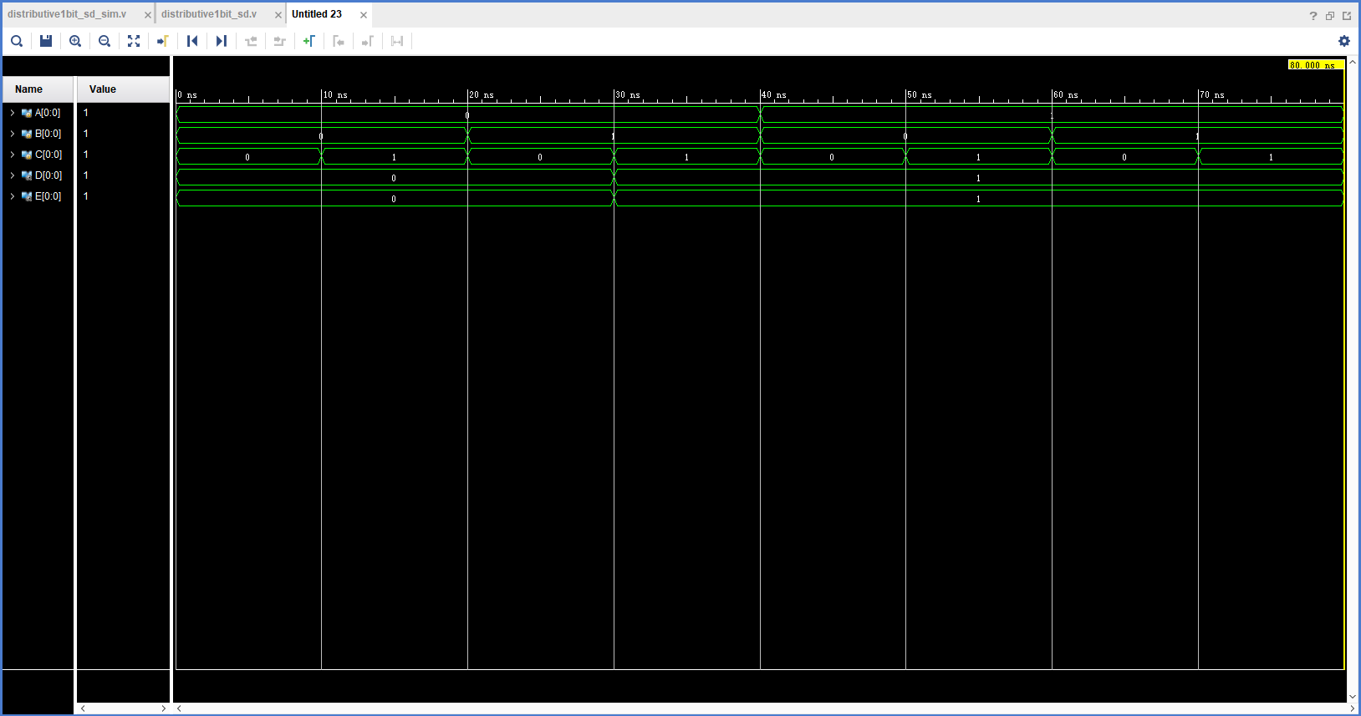

**The result of simulation is the same as the truth table, the function of the design meets the expectation correctly.**

**In addition, I use while to reduce repetitive work.**

### (B)

#### Task2_b_2bit_sim

`timescale 1ns / 1ps  
module distributive1bit_sd_sim();  
 reg[1:0] A, B, C;  
 wire[1:0]D, E;  
 distributive2bit_sd dis(A, B, C, D, E);  
 //or distributive2bit_df dis(A, B, C, D, E);  
 initial  
 begin  
 A = 'b0;B = 'b0;C = 'b0;  
 while({A, B, C}<'b111111)begin  
 #10 {A, B, C} = {A, B, C} + 1;  
 end  
 end  
 initial #640 $finish;  
endmodule

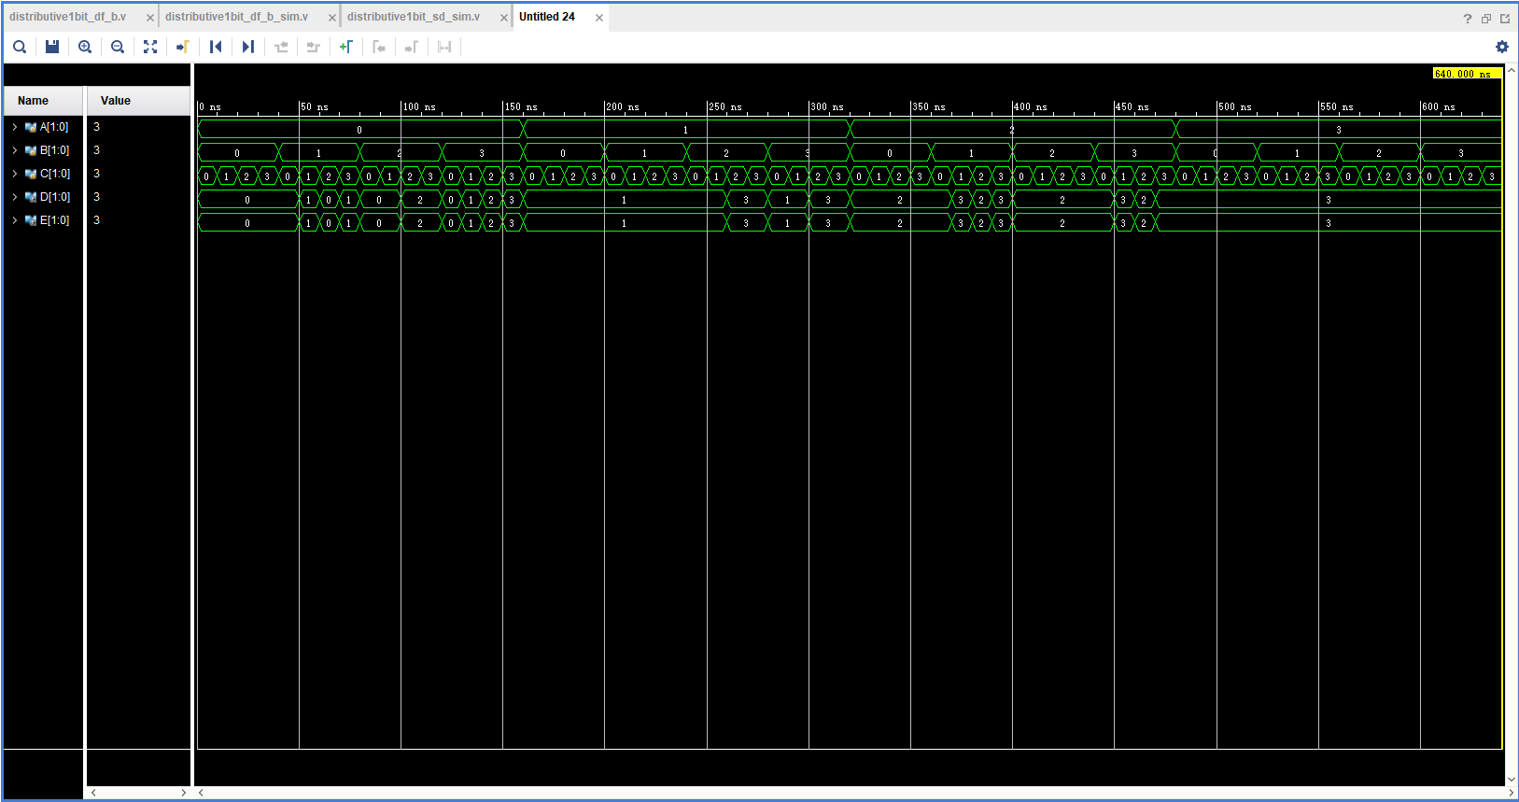

**The result of simulation is the same as the truth table, the function of the design meets the expectation correctly.**

**In addition, I use while to reduce repetitive work.**

##### the description of operation

*Describe the problem occurred while in the lab and your solution. Any suggestions are welcomed.*

* *Problems and solutions*

**When I write task2, I realize that It’s so boring and meaningless to write 64 cases. So, I learn how to write generation in Verilog. It turns out that it works well.**